**SIX WEEKS INSTITUTINAL TRAINING**

**Programming in Java**

**Project Report**

**Bachelor of Technology**

**In**

**Computer Science Engineering**

**Batch**

**(2017 – 2021)**



SUBMITTED TO:-SUBMITTED BY:

**Er.Vinod Sharma(H.O.D /CSE) AayushKhanna (1701214)**

**Nikhil Chopra (1701317)**

**UdayMahajan(1701391)**

**ACKNOWLEDGEMENT**

This is a humble effort to express our sincere gratitude towards those who have guided and helped us to complete this project

A project is major milestone during the study period of a student. As such this project was a challenge to us and was an opportunity to prove our caliber. We are highly grateful and obliged to each and everyone making us help out of problems being faced by us.

We AayushKhanna , Nikhil Chopra and UdayMahajan considering ourselves a very fortunate of getting an opportunity to conduct the training approval and project assignment by **REAL INFOTECH.** We got opportunity to get a practical exposure into actual environment and it provides us a golden opportunity to make our theoretical concept of language in more clear way.

We are able to learn very new thinga that are really helpful for us.

We woul like to thank our special thanks to **Er. Vinod Sharma** head of CSE department and the faculty members of department and the faculty members of the department for providing us the opportunity to do six weeks industrial training.

It would not have been possible to see through the undertaken project without the guidance of **Mr.UmeshKalia**. It was purely on the basis of their experience and knowledge that we able to clear all the theoretical and technical hurdles during the development phases of this project work.

**DECLARATION**

We hereby declare that the project work entitled **“Employee Monitoring System”**is an authentic record of our work carried out as requirements of Institutional Training project for the award of degree of **Btech CSE** , **Real Infotech** under the guidance of **Mr.Umesh Kalia**

(Signature of students)

**Aayush Khanna (1701214)**

**Nikhil Chopra(1701314)**

**Uday Mahajan (1701391)**

INDEX PAGE

|  |  |  |
| --- | --- | --- |
| Sno | Contents | Page No |
| 1 | About The Organization | 5-6 |
| 2 | Technologies | 7-9 |
| 3 | Introduction to JAVA | 10-12 |
| 4 | About Net beans | 13-14 |
| 5 | Hardware and Software Requirements | 15 |
| 6 | About Project | 16-17 |
| 7 | About Modules Used | 18-19 |
| 8 | Snapshots of GUI Project | 20-25 |
| 9 | Snapshots of Tables created in Oracle | 26-28 |
| 10 | Suggestion and Recommendation | 29 |
| 11 | Bibliography | 30 |

**TRAINING OBJECTIVES**

Theoretical knowledge about practical understanding is of no use. Most of the technical institutes are not able to run with the fast rate of change in industry, which is now open to global competition.

The main objective of the industrial training is to enable the student to appy the theoretical knowledge to the practical situation and to expose themselves to corporate environment. Industrial training is very important part of study curriculum in engineering education field. We, being a student of B.Tech in CSE at ACET, Amritsar is supposed to undergo six weeks industrial training in our field of interest. During which we got a chance to increase our practical knowledge. The objective of this training is to learn new technology that will be very helpful in future for us. The another main objective is to make the project by our own that would help us to explore more about technology and increase our practical knowledge. In this training we came to know about very beautiful features of Core Java that would be very beneficial for us to make projects, applications and softwares in future. Java is most secured and all the banking systems preferred java for developing the softwares. In this training we are able to learn GUI based features of java. Database connectivity is learned by us in this training. We feel the most of the objective quoted were fulfilled.

**ABOUT THE ORGANIZATION**



**Organisation Profile**

Real Infotech was established with the aim to provide “Quality IT Training”. The tremendous progress made by the institute and the reputation it commands today is an ample testimony of its commitment to quality.

Over the years, Real Infotech has gained deep insight and expensive experience in the field of information technology. Constantly broadening and upgrading its technology base and areas of expertise, Real Infotech has vision which sees itself in the league with the best of world class IT solution providers.

During the last few years, Real Infotech has established itself as well known entity in the field of IT education. Real Infotech keeps on applying research methodology and innovative techniques to utilize the technology for training and development, which makes it a favorites training organization for Engineering graduates, MCAs and IT professionals.

Real Infotech has rich training programmes for upcoming IT professionals, which not only enables them to fulfill their academic needs, but make them technically sound for IT industry.

**Training at Real Infotech**

Real Infotech provides the most comprehensive Hi-End technology courses for IT Professionals and aspiring IT students. The objective of training programmes is to bridge the gap between the practical knowledge level of IT Professionals and the current requirements of the IT industry. Keeping this in mind, Real Infotech has chalked out some extensive training programmes, which makes students technically sound for the booming IT industry. Training programmes help students to develop analytical and problem solving capability, logical skills and practical experience in line with the latest industry standards. Its carefully designed training programmes ensure that each student should get informed of the latest infra-structure in the IT industry. Real Infotech caters to the ever growing needs of the global technically advances in the IT Sphere. The academic as well as technical experience gained by students in the institute prepares them suitably to the expectations of the major stalwarts of the IT industry such as Infosys, Wipro, TCS, Accenture & many more.

**TECHNOLOGIES**

**FRONT-END: JAVA**

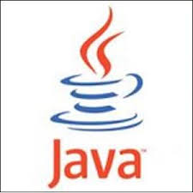

**Java** is a set of several computer software products and specifications from Sun Microsystems (which has since merged with Oracle Corporation), that together provide a system for developing application software and deploying it in a cross-platform computing environment. Java is used in a wide variety of computing platforms from embedded devices and mobile phones on the low end, to enterprise servers and supercomputers on the high end. While less common, Java applets are sometimes used to provide improved and secure functions while browsing the World Wide Web on desktop computers.

Writing in the Java programming language is the primary way to produce code that will be deployed as Java bytecode. Java eliminates certain low-level constructs such as pointers and has a very simple memory model where every object is allocated on the heap and all variables of object types are references. Memory management is handled through integrated automatic garbage collection performed by the JVM.

## Platform

An edition of the Java platform is the name for a bundle of related programs from Sun that allow for developing and running programs written in the Java programming language. The platform is not specific to any one processor or operating system, but rather an execution engine (called a virtual machine) and a compiler with a set of libraries that are implemented for various hardware and operating systems so that Java programs can run identically on all of them.

* Java Card: A technology that allows small Java-based applications (applets) to be run securely on smart cards and similar small-memory devices.
* Java ME (Micro Edition): Specifies several different sets of libraries for devices with limited storage, display, and power capacities.
* Java SE (Standard Edition): For general-purpose use on desktop PCs, servers and similar devices.
* Java EE (Enterprise Edition): Java SE plus various APIs useful for multi-tier client–server enterprise applications.

The Java platform consists of several programs, each of which provides a portion of its overall capabilities. For example: the Java compiler, which converts the Java source code into Java bytecode (an intermediate language for the JVM), is provided as part of the Java Development Kit (JDK). The Java Runtime Environment (JRE), complementing the JVM with a just-in-time (JIT) compiler, converts intermediate bytecode into native machine code on the fly. An extensive set of libraries are also part of the Java platform.

The essential components in the platform are the Java language compiler, the libraries, and the runtime environment in which Java intermediate bytecode "executes" according to the rules laid out in the virtual machine specification.

**BACK-END : ORACLE 10g**

The Oracle Database (commonly referred to as Oracle RDBMS or simply as Oracle) is an object-relational database management system produced and marketed by Oracle Corporation. Larry Ellison and his friends, former co-workers Bob Miner and Ed Oates, started the consultancy Software Development Laboratories (SDL) in 1977. SDL developed the original version of the Oracle software.

## Physical and logical structures

An Oracle database system—identified by an alphanumeric system identifier or SID—comprises at least one instance of the application, along with data storage. An instance—identified persistently by an instantiation number—comprises a set of operating-system processes and memory -structures that interact with the storage Oracle documentation can refer to an active database instance as a "shared memory realm".

If the Oracle database administrator has implemented Oracle RAC (Real Application Clusters), then multiple instances, usually on different servers, attach to a central storage array. This scenario offers advantages such as better performance, scalability and redundancy. However, support becomes more complex, and many sites do not use RAC. In version 10*g*, grid computing introduced shared resources where an instance can use (for example) CPU resources from another node (computer) in the grid.

The Oracle DBMS can store and execute stored procedures and functions within itself. PL/SQL(Oracle Corporation's proprietary procedural extension to SQL), or the object-oriented language [Java](http://en.wikipedia.org/wiki/Java_(programming_language)" \o "Java (programming language))can invoke such code objects and/or provide the programming structures for writing them.0

**FEATURES:**

* Active Session History (ASH), the collection of data for immediate monitoring of very recent database activity.
* Automatic Workload Repository (AWR), providing monitoring services to Oracle database installations from Oracle version 10. Prior to the release of Oracle version 10, the Stats pack facility provided similar functionality.
* Database Resource Manager (DRM), which controls the use of computing resources.
* Fine-grained auditing (FGA) (in Oracle Enterprise Edition) supplements standard security-auditing features.
* ISQL*Plus, a web-browser-based graphical user interface (GUI) for Oracle database data-manipulation.
* Oracle-managed files (OMF) -- a feature allowing automated naming, creation and deletion of data-files at the operating-system level.
* Recovery Manager  (rman) for database backup, restoration and recovery
* SQL*Plus, a program that allows users to interact with Oracle database(s) via SQL and PL/SQL commands on a command-line. Compare iSQL*Plus.
* Universal Connection Pool (UCP), a connection pool based on Java and supporting JDBC, LDAP, and JCA.
* Virtual Private Database (VPD), an implementation of fine-grained access control.

**INTRODUCTION TO JAVA**

Java is a programming language created by James Gosling from Sun Microsystems (Sun) in 1991. The target of Java is to write a program once and then run this program on multiple operating systems. The first publicly available version of Java (Java 1.0) was released in 1995. Sun Microsystems was acquired by the Oracle Corporation in 2010. Oracle has now the steermanship for Java. In 2006 Sun started to make Java available under the GNU General Public License (GPL). Oracle continues this project called OpenJDK*.*

Over time new enhanced versions of Java have been released. The current version of Java is Java 1.8 which is also known as Java 8*.*

Java is defined by a specification and consists of a programming language, a compiler, core libraries and a runtime (Java virtual machine) The Java runtime allows software developers to write program code in other languages than the Java programming language which still runs on the Java virtual machine. TheJava platform is usually associated with theJava virtual machine and the Java core libraries*.*

**JAVA VIRTUAL MACHINE**

The Java virtual machine (JVM) is a software implementation of a computer that executes programs like a real machine.

The Java virtual machine is written specifically for a specific operating system, e.g., for Linux a special implementation is required as well as for Windows.

Java programs are compiled by the Java compiler into bytecode*.* The Java virtual machine interprets this bytecode and executes the Java program.

**JAVA RUNTIME ENVIRONMENT vs. JAVA DEVELOPMENT KIT**

A Java distribution typically comes in two flavors, the Java Runtime Environment (JRE) and the Java Development Kit (JDK).

The JRE consists of the JVM and the Java class libraries. Those contain the necessary functionality to start Java programs.

The JDK additionally contains the development tools necessary to create Java programs. The JDK therefore consists of a Java compiler, the Java virtual machine and the Java class libraries.

### [DEVELOPMENT](http://www.vogella.com/tutorials/JavaIntroduction/article.html?utm_source=tuicool#development-process-with-java) PROCESS WITH JAVA

Java source files are written as plain text documents. The programmer typically writes Java source code in an Integrated Development Environment(IDE) for programming. An IDE supports the programmer in the task of writing code, e.g., it provides auto-formatting of the source code, highlighting of the important keywords, etc.

At some point the programmer (or the IDE) calls the Java compiler ( javac ). The Java compiler creates the bytecode instructions. These instructions are stored in .class files and can be executed by the Java Virtual Machine.

### [GARBAGE](http://www.vogella.com/tutorials/JavaIntroduction/article.html?utm_source=tuicool#garbage-collector) COLLECTOR

The JVM automatically re-collects the memory which is not referred to by other objects. The Java garbage collectorchecks all object references and finds the objects which can be automatically released.

While the garbage collector relieves the programmer from the need to explicitly manage memory, the programmer still need to ensure that he does not keep unneeded object references, otherwise the garbage collector cannot release the associated memory. Keeping unneeded object references are typically called memory leaks*.*

### [CLASSPATH](http://www.vogella.com/tutorials/JavaIntroduction/article.html?utm_source=tuicool#classpath)

The classpathdefines where the Java compiler and Java runtime look for .class files to load. These instructions can be used in the Java program.

For example, if you want to use an external Java library you have to add this library to your classpath to use it in your program.

**FEATURES OF JAVA**

* **COMPILED AND INTERPRETER**: It has both compiled and interpreter feature. Program of java is first compiled and then it is must to interpret it.
* **PLATFORM INDEPENDENT**: Java language is platform independent means program of java is easily transferable because after compilation of java program byte codes will be created, then we just transfer the code of byte code to another computer.
* **OBJECT ORIENTED**: Java is purely OOP language that is all the code of java language is written into the classes and objects. So for this feature java is most popular language because it also supports Code Reusability, Maintenance etc.
* **MULTITHREADED:** Java use multithreaded techniques for execution means. Code of java executed in sequence and timing manner is called as multithreaded. In this program of java is divided into small parts those are executed by compiler of java is called as interactive.
* **DYNAMIC AND EXTENSIBLE CODE**: Java has dynamic and extensible code means with the help of OOPS. Java provides inheritance with which we reuse the code that is predefined.
* **PORTABLE**: Java programs can execute in any environment for which there is Java run time system (JVM). Java programs can be run on any platform.
* **HIGH PERFORMANCE**: Byte codes are highly optimized. JVM can execute them much faster.
* **SECURED:** Java is secured because no explicit pointer is required and programs run inside virtual machine sandbox.
* **ROBUST**: Java has a strong memory allocation and automatic garbage collection mechanism. It provides the powerful exception handling and type checking mechanism as compared to other programming language.

**TOOLS USED**

**Netbeans - integrated development environment**

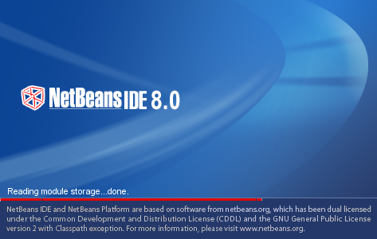

**Net Beans**IDE is a free, open source, popular integrateddevelopment environmentused by many developers. Out of the box, it provides built-in support fordeveloping in Java, C, C++, XML, and HTML. And this author especially likes the support for editingJSPs, including syntax highlighting, HTML tag completion, JSP tag completion, and Java codecompletion.

The basic steps for making a new project in java are as follows.

1. Create a new project

2. Mount a directory - specify a location to save project files

3. Add a new class to the project

4. Compile and run a Java program

**SOFTWARE AND HARDWARE REQUIREMENTS**

**Hardware Requirements:**

|  |  |
| --- | --- |
| **Hardware Requirements** | |
| RAM (random access memory) | 2 GB |
| Hard disk | 20 GB |
| Monitor | SVGA(video graphic adaptor) |
| Processor | 1.5 GHz or Higher Pentium-compatible CPU |

**Software Requirements :**

|  |  |
| --- | --- |
| **Software Requirements** | |
| **Java Runtime Environments** | JRE 1.5 or higher, JDK 5 or higher |
| Operating System | Windows XP or above , Linux, Mac |
| RDBMS | Oracle 10g |
| IDE | Netbeans 7 or higher (for Development) |

**ABOUT PROJECT**

**Introduction to Project:-**

**Aim :-**The aim of project is to monitor the performance of each employee.

The name of our Project name is “Employee Monitoring System”. This project is made using connectivity with Oracle.

Our application is based on keeping the record of each and every employee in a single framework which is useful for many MNC’s.

Working of the project:

1. **Login:**

The application will consist of two login windows:-

1.Admin Login Window

2. Employee Login Window

**Admin Login Window:**

A username and a password will be provided to the Administrative department of the company.

**Employee Login Window:**

A separate username and a password will be provided to the Employee members which are a part of any department in the company.

1. **Roles**

**Role of Admin:**

* This is the main module mentioned above. This module has all control of the project.
* Let’s suppose there’s any project which is going to take place in any college eg.an app for messaging.
* The admin will login into his/her account and will be connected to the group page which will consists of various text fields like group id, task id, number of members
* The admin will be connected to the task page which will consists of various textfields like task id , task name, deadline , start date, points and description.
* Each and every control of data entry, data deletion and data updation is taken care by Admin module.

**Roles of Employee:**

* This is the second module of project which has further sub menus.
* Employee will login through their login page which consists of the two two text fields username and password.
* Employee table consists of various text fields emp id , emp name, dept id, designation , salary , hiredate , sex, emp_country , contact info, marital status , group id, task id, email.

**Rights provided to Admin**

* Admin can insert , delete and modify the record of any employee.
* Admin can change the password given to him.
* Tasks /Projects are assigned to Project Manager by the admin.
* Admin can also edit project detailsand can review it too.

**Rights provided to Employee**

* Employee can view his details and cannot edit it.
* Employee can change his login password.
* Employee can view the task assign to him.
* Employee cannot edit their information.

Employees are divided into categories:-

* **Project Manager:-** Project Manager will allocate the project to Team Leader and also form teams.
* **Team Leader:-** Team Leader will allocate the modules to team Members
* **Team Member:-**Team Member will view their details and are able to see modules assigned to them.

**Modules used in Project:-**

The proposed system “**Employee Monitoring System”**consists of twomain modules. For using these modules firstly login with valid username and password. Firstly the login panel contains two buttons “**Login as admin”** and **“Login as Employee”.** Both **“Login as admin panel**” as well as **“Login as Employee panel”**consists of separate username and password. And after login correctly it will open the required panel.

The following main modules of the project are:-

* **Admin**
* **Employee**

The above mention modules have their own specifications and have further different modules that really make things effective and much easier. The modules are discussed below:

* **Admin.**

The main module of the project is mentioned above. This module has all the controls of the project. Each and every control of data entry, data modification and data deletion is taken care by Admin module. This module has further different modules with their own specifications. It contains two menus. These are as follows:-

1. **Menu:-** This menu bar lies at top left of the Admin frame by clicking on which admin can see menu items:- **Change Password, Logout, Exit.**
2. **Change Password:-**It allows admin to change the Login password of the account. For changing the password, admin must remember previous password.
3. **Logout:-**Logout will close the Admin frame and will return back to Login menu.
4. **Exit:-** Exit will close the project
5. **Edit:-**This menu bar lies next to **“Menu”**in Admin Frame. By clicking on which admin can see menu items:-**Employee Detail, Project Detail, Project Assign , Team.**
6. **Employee:-** It allows admin to insert , modify and delete the employee record which contains

* Employee id
* Name
* Gender
* Salary
* Hire date
* Address ,
* Email
* Designation
* Contact number
* Username
* Date of birth
* Marital status
* Password.

1. **Project :-** It allows admin to insert, delete and modify the project details which contains

* Project id
* Project title
* Modules
* Description
* Start date
* End date.

1. **Modules :-**It allows admin to assign project to assign project to project Manager.
2. **Project assign:-**It allows admin to assign project to project manager.
3. **Performance:-** This menu will display the employee performance to admin.

* **Employee.**

The second module of the project is mentioned above. This module also have menus in it. For assessing it employee must have valid username and password. These menus are as follows:-

* 1. **Menu:-** This menu bar lies at top left of the Admin frame by clicking on whichemployee can see menu items:- **Change Password, Logout, Exit.**

1. **Change Password:-**It allows employee to change the Login password of the account. For changing the password ,employee must remember previous password.
2. **Logout:-**Logout will close the employee frame and will return back to Login menu.
3. **Exit:-**Exit will close the project.
   1. **View:-**This menu bar lies next to menu option and it contains following menu options:- **Employee details , project details.**
4. **Employee details:-**Employee can only view the general details of his own which is inserted by the admin.
5. **Project details:-**This will show the project details to employee which are assigned to employee.

**SNAPSHOTS**

**Login Page:-**

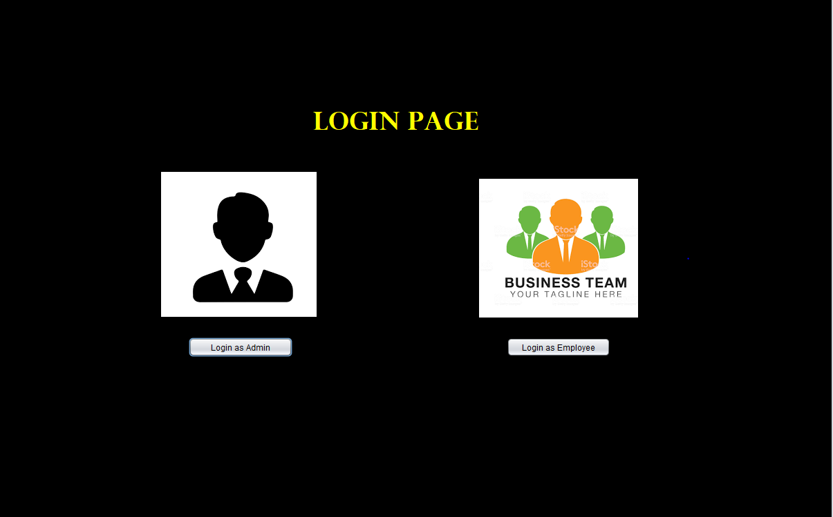

There are two options in login page if login as admin is clicked then admin sign up window will appear.

**Admin Sign Up:-**

If user will fill valid email and valid password then it will open admin frame otherwise it will show an error.

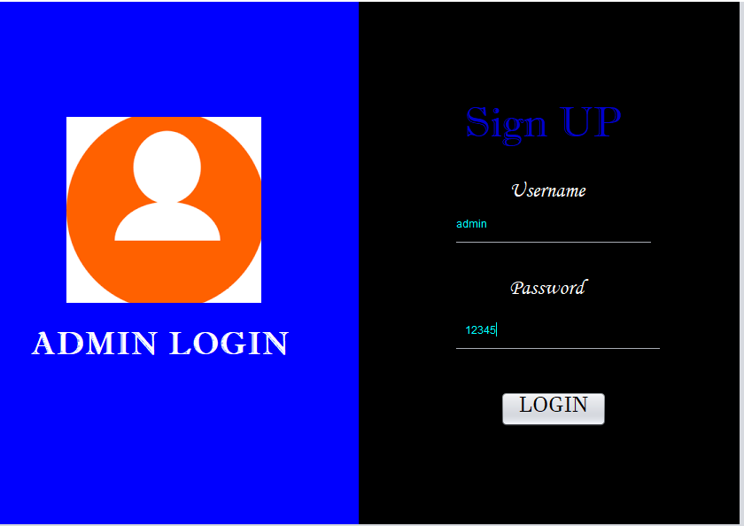

Error Message

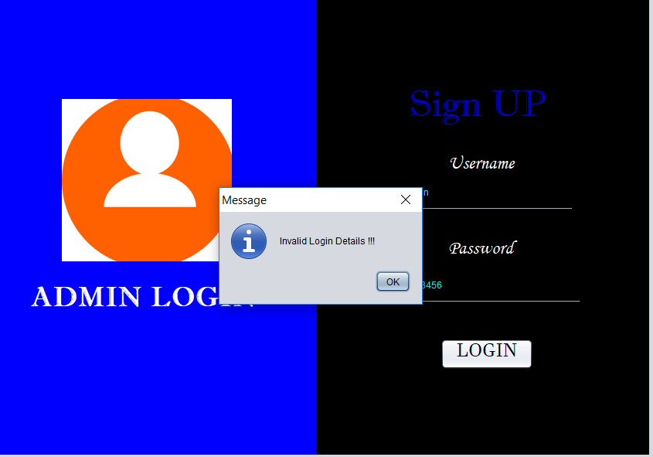

After filling right details admin Frame is opened.

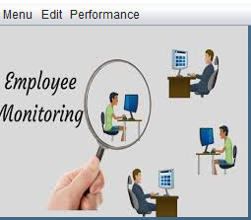

There are several menu in admin frame :- Menu, Edit and Performance

* Change Passsword:-

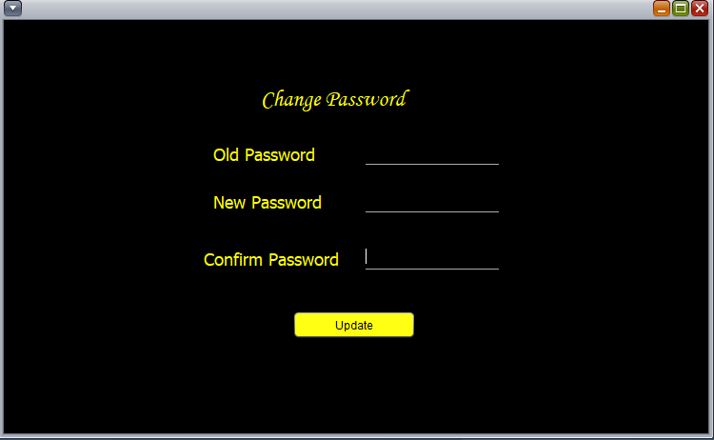

Password Changed

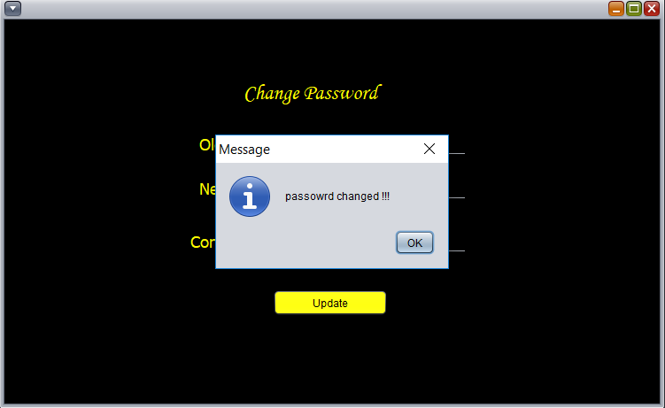

* In Edit there is employee table where admin enter , delete and modify data of different employees. And all the data is shown in the table below

Update Data:-

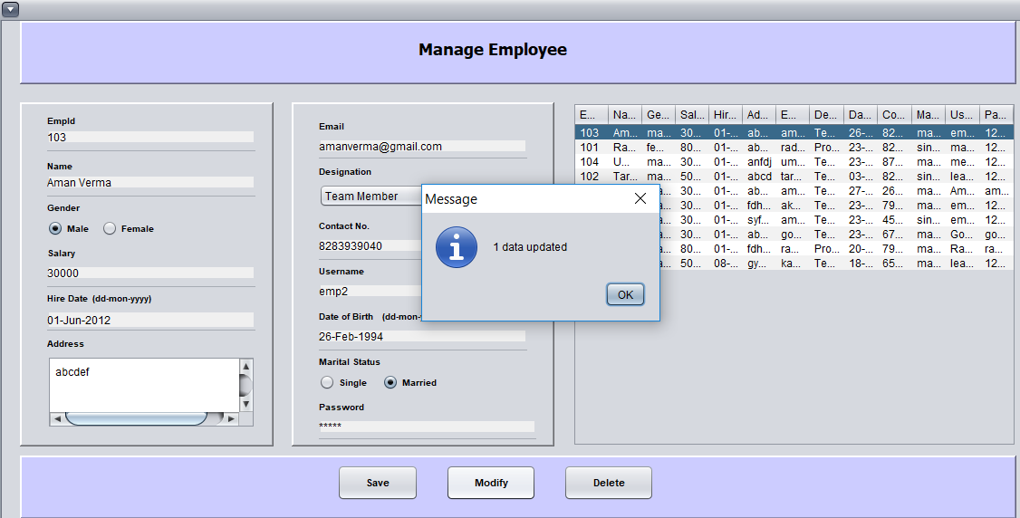

Delete Employee Data:-

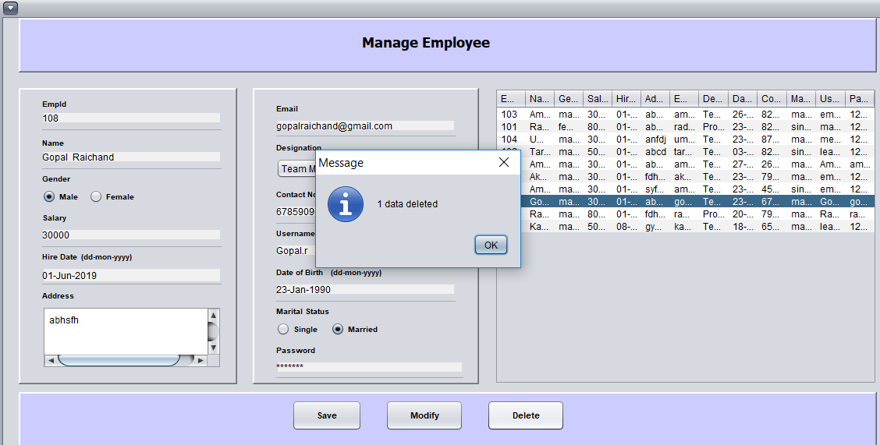

Save Data:-

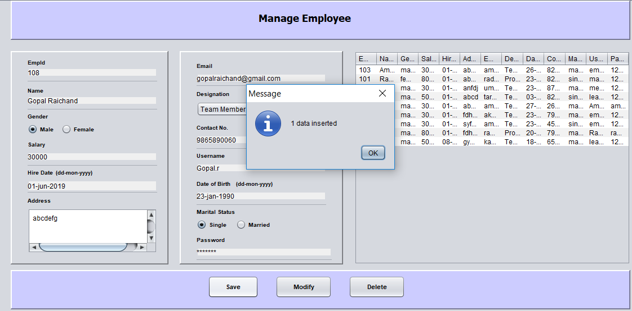

In Edit there is project option where you can add , delete or modify project details.

Insert project details

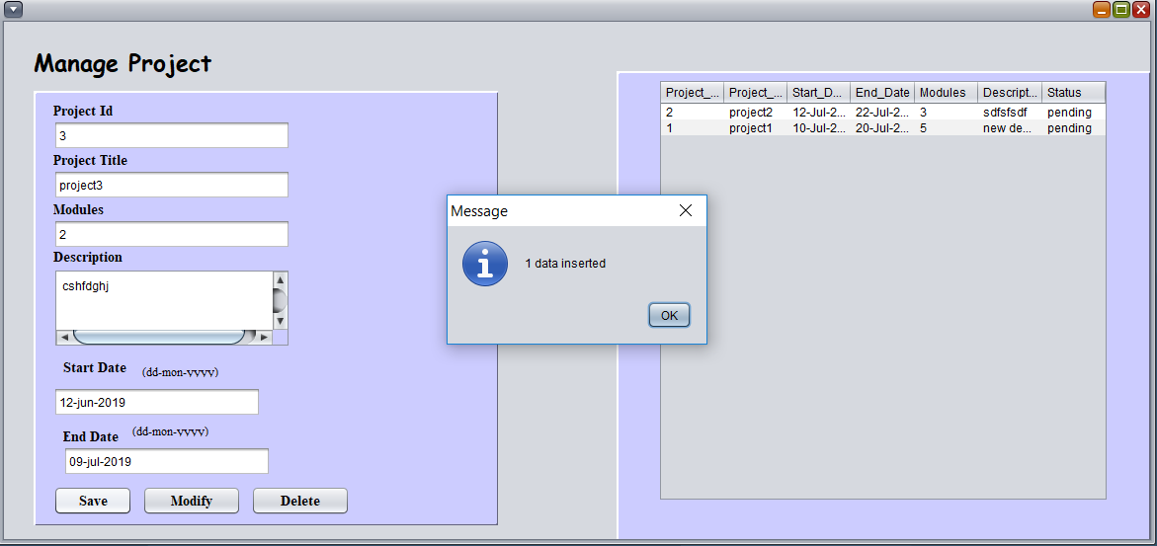

Delete Project Details

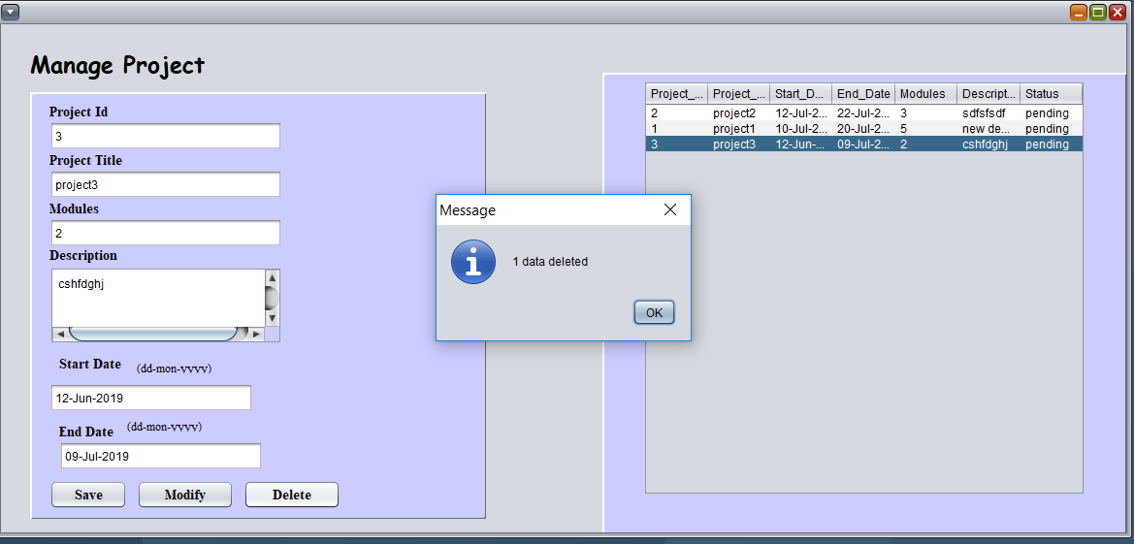

In Perfromance The performance of employees are shown

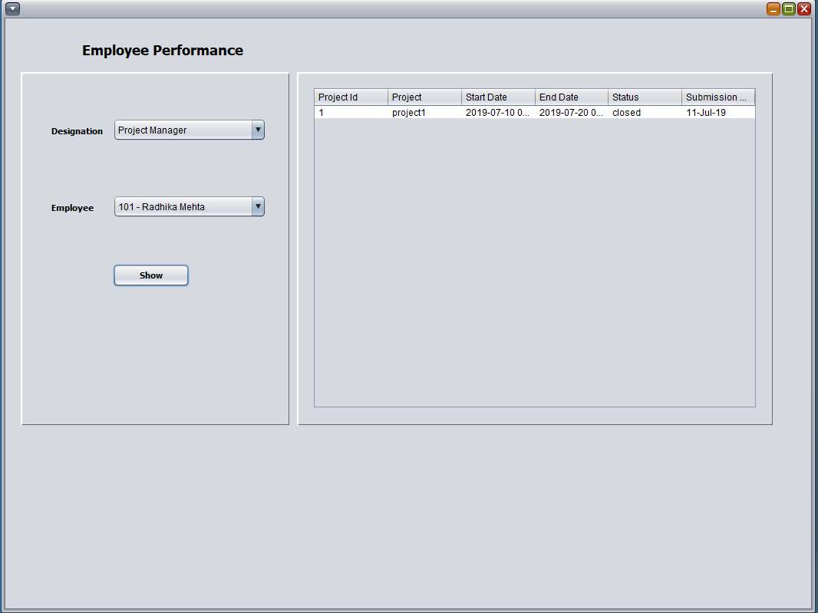

**Employee Sign Up:-**

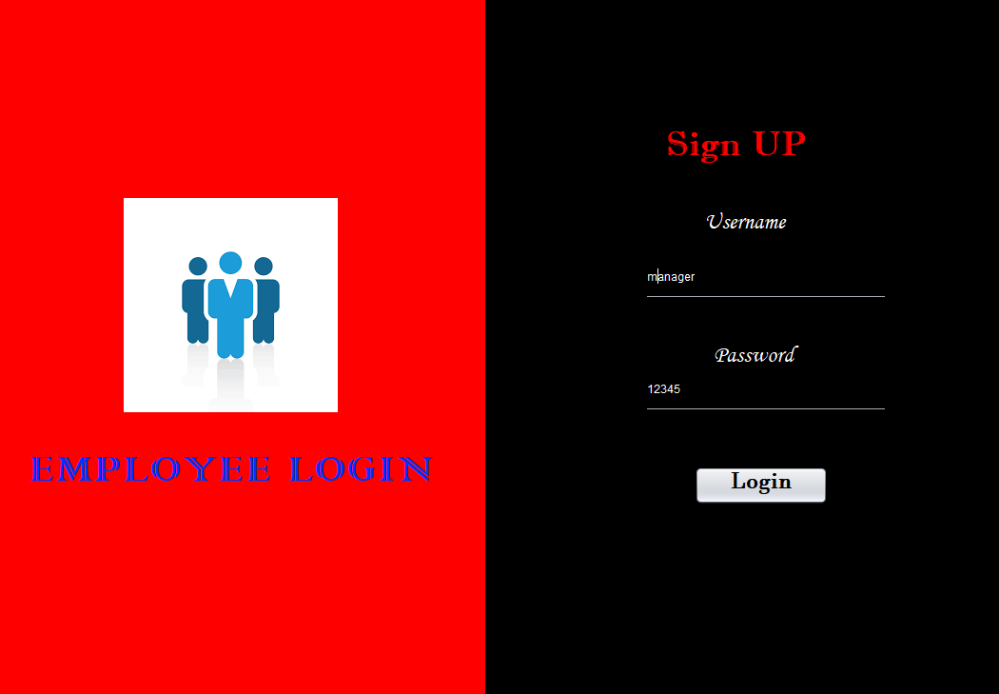

After filling correct login username and password of employee employee frame will appear

There will be two menus in that frame where in first there will be option of change password , logout and exit

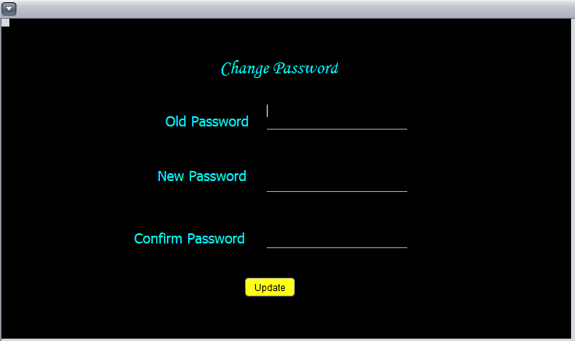

Password Changed:

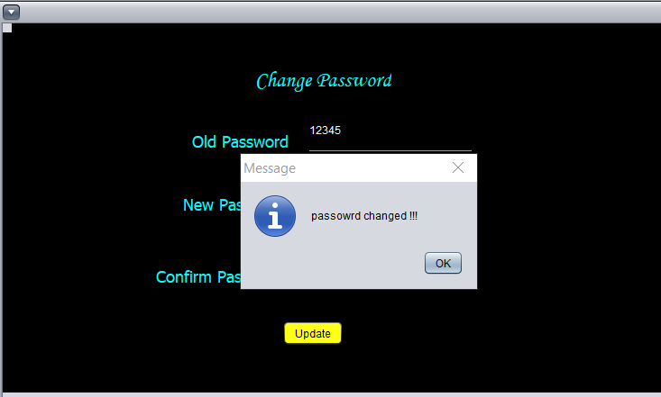

In view menu there are options

* View Employee:- In which the general details of employee are shown

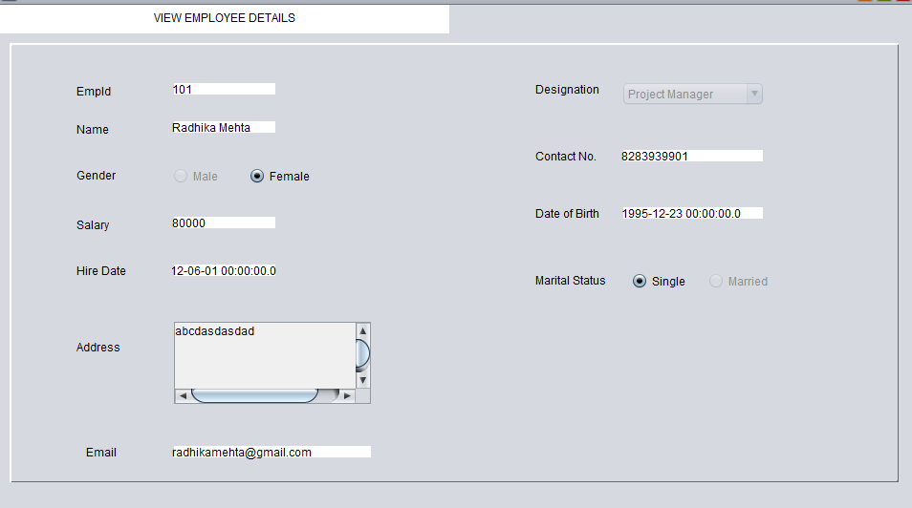

In Project manager there is my project option:-

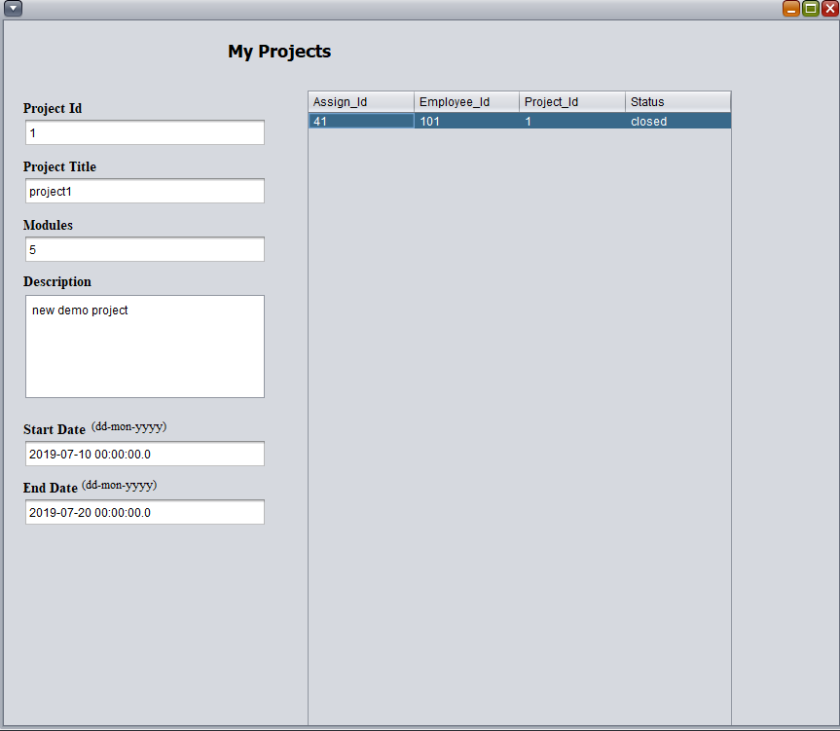

There is another option of my team

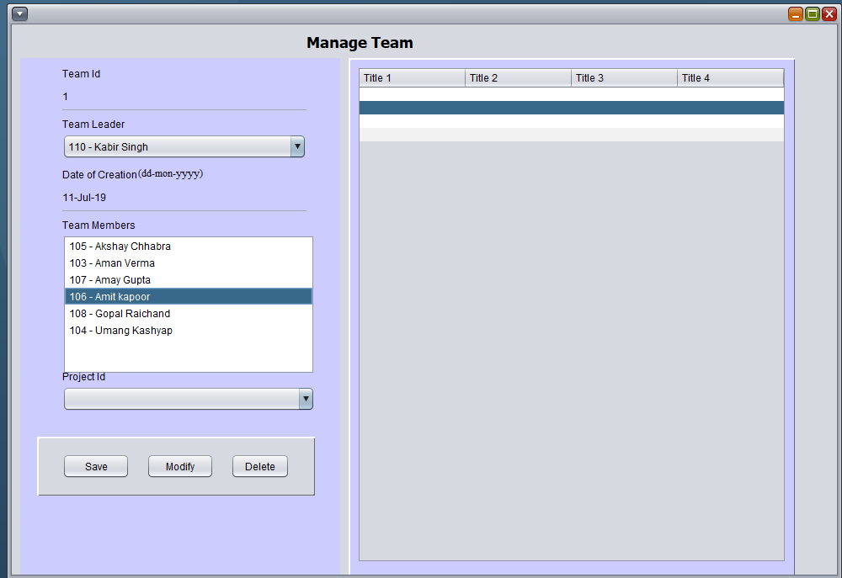

Another dialog box of view team status

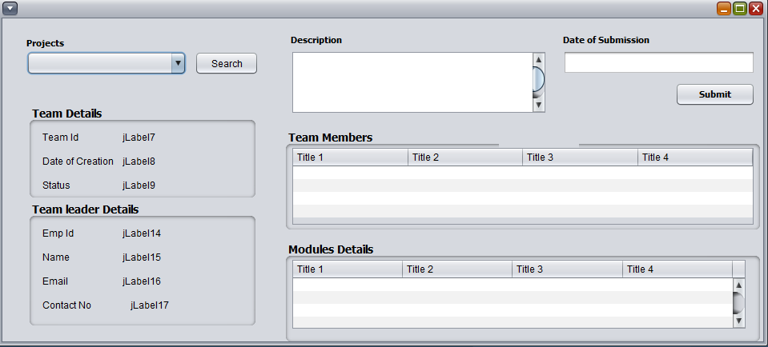

View Modules

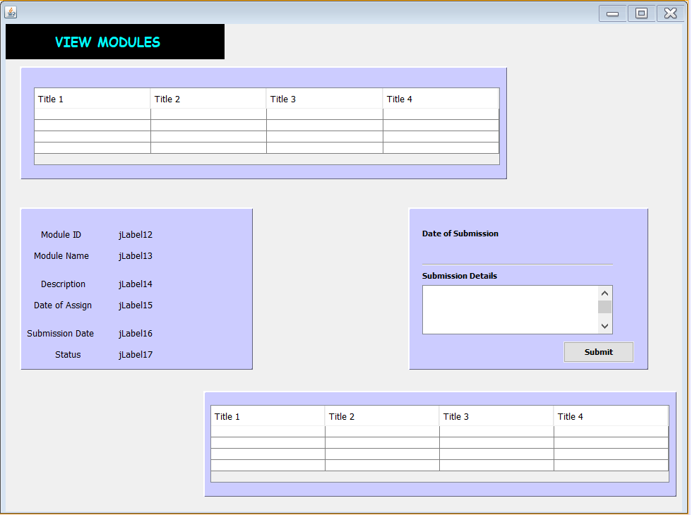

View Module Status

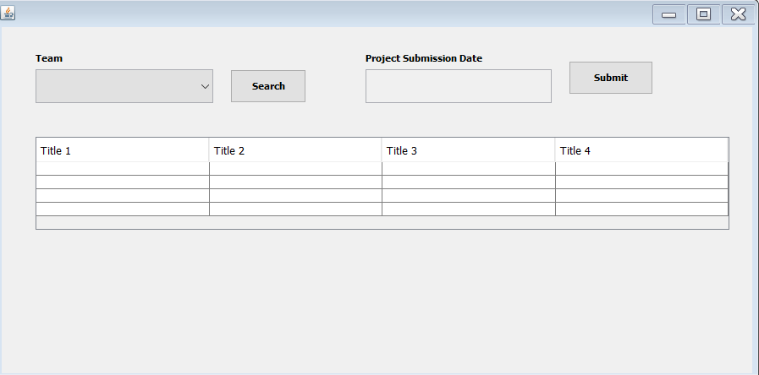

Different tables are made at the backend i.e in Oracle 10g. And the are connected to netbeans. So that whatever changes are made at the front end all are saved at the backend.

**Employee Table**

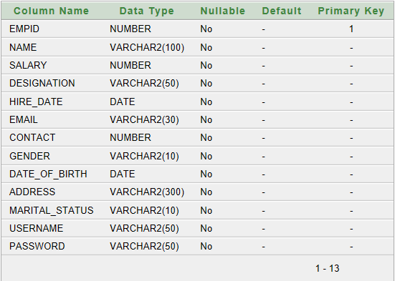

**Admin table**

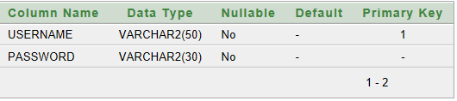

**Module assign table**

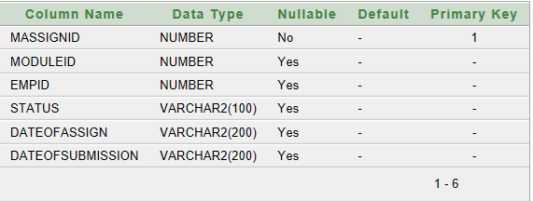

**Modules Table**

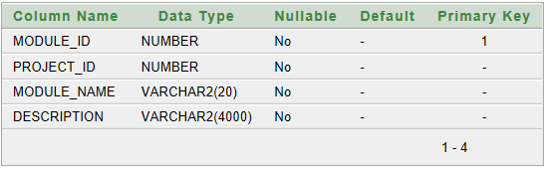

**Module Submission Table**

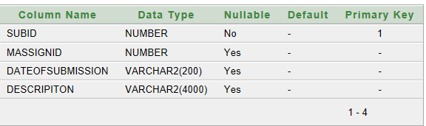

**Team Members Table**

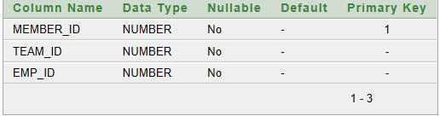

**Project Table**

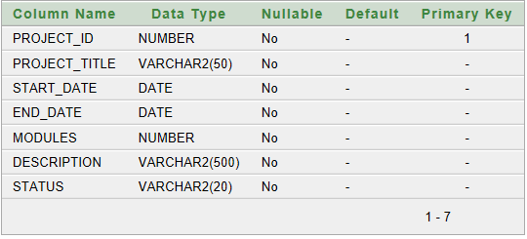

**Project Assign Table**

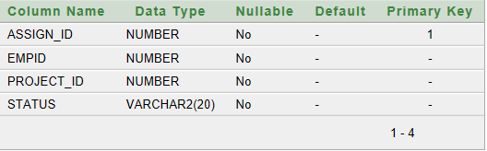

**Team Table**

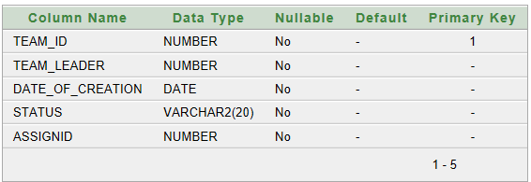

**Team Submission table**

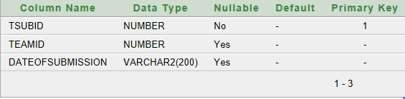

**Project Submission**

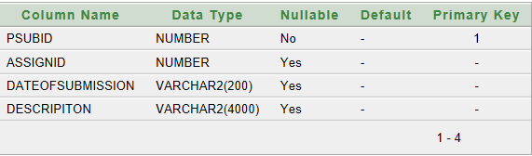

**SUGGESTIONS AND RECOMMENDATIONS**

As per the project module , this project is very much helpful in managing the record of employee in MNCs to reduce the burden. By opting this idea many new advance features can introduce in this project too.

Her user can log in from college only but not from home so by making this idea as a base this project can be made in this way so that user can login from anywhere.

This can be implemented as the additional feature of the proposed system.

**BIBLIOGRAPHY**

**Web Urls:-**

The online java tutorials @http://docs.oracle.com/javase/tutorial.

[www.wikioedia.com](http://www.wikioedia.com)

[www.developer.com/java/](http://www.developer.com/java/)

<https://www.javaworld.com>

<http://www.udemy.com/sql>

**BOOKS**

Java : The Complete Reference Ninth. Edition

Oracle 8i :- The Complete Reference